Problem description

ABC Bank wants to sell its term deposit product to customers and before launching the product they want to develop a model which help them in understanding whether a particular customer will buy their product or not (based on customer's past interaction with bank or other Financial Institution).

Business understanding:
Bank wants to use ML model to shortlist customer whose chance of buying the product is more so that their marketing channel (tele marketing, SMS/email marketing etc.) can focus only to those customers whose chance of buying the product is more.

This will save resource and their time (which is directly involved in the cost (resource billing)).

Project lifecycle along with deadline
We will follow the CRISP-DM lifecycle.

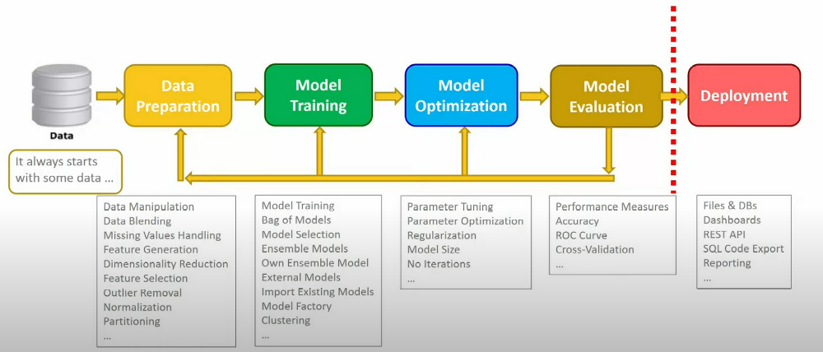

Data Intake Report

Name: Bank Marketing (campaign)
Report date: 08/25/2022
Internship Batch: LISUM11: 30
Version: 1.0
Data intake by: Priyadarshani Kamble
Data intake reviewer: NA
Data storage location: https://archive.ics.uci.edu/ml/datasets/Bank+Marketing/ bank-additional-full.csv

Tabular data details:

Total number of observations | 41188
Total number of files | 1
Total number of features | 21
Base format of the file | csv
Size of the data | 5699kb

Note: Replicate same table with file name if you have more than one file.

Proposed Approach:
- Objective function:
Predict the subscribe (yes/no) attribute which is indicator to show if the client will subscribe a term deposit.
- Data strategy:
The data is available in csv file. The Key attributes include age, job, marital, education, default, balance, housing loan, contact, day, month, duration, campaign, pdays, previous, poutcome, y
- Understanding the Data:
Perform data cleaning/wrangling if needed. e.g., duplicate, and missing data handling. Observe relationships between features by performing exploratory analysis also share other insights of the data.
- Modelling approach:
This will be supervised machine learning problem which will involve using classifications models to predict to predict if the client will subscribe (yes/no) a term deposit (variable y)

